**9/11**

[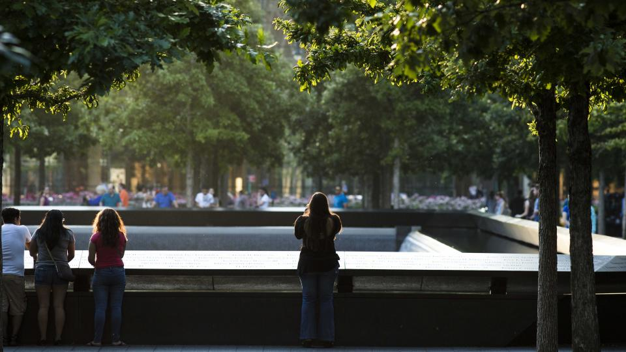](https://www.911memorial.org/)

FLIGHT 11 and FLIGHT 175

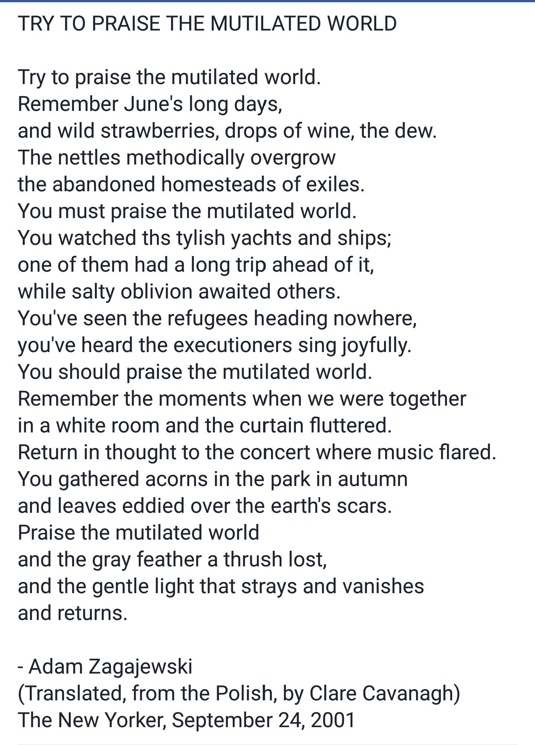

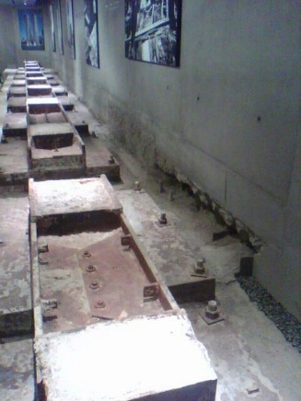

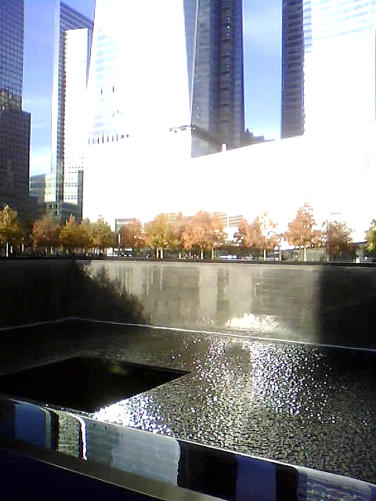the **9/11** Memorial Museum (lower floor)

(image Nov. 6, 2013)

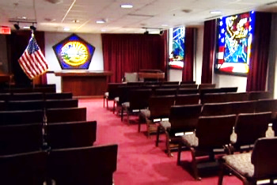[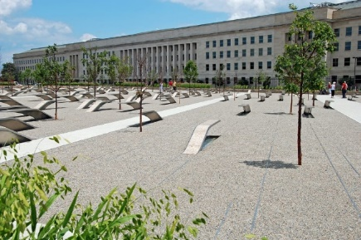](https://www.defense.gov/Multimedia/Experience/Pentagon-Memorial/)

FLIGHT 77, The Pentagon,

Arlington County,

Virginia

|  |  |  |  |  |
| --- | --- | --- | --- | --- |
|  | | FLIGHT 93, Somerset County,Pennsylvania | | |
| the hijacker letter (https://www.flight93friends.org/learning-center/crime-scene-investigation/the-last-night-document) | | [undefined](https://www.flight93friends.org/learning-center/crime-scene-investigation/the-last-night-document) |

***

E. (Erik) van der Kooij   
Director Feeling Europe Foundation

 [www.feelingeurope.eu](https://www.feelingeurope.eu/)

[✉](mailto:contribute@feelingeurope.eu) [contribute@feelingeurope.eu](mailto:contribute@feelingeurope.eu)

[](https://www.linkedin.com/in/feeling-europe-foundation/) [](https://x.com/feeling_europe)

[](https://x.com/C21fellow) C21fellow

_________________________________________________________

Centers involved:

- [Nexus Institute](https://nexus-instituut.nl/en/?noredirect=en-US)

- [Leiden University](https://www.universiteitleiden.nl/en)

- [Caux Round Table for Moral Capitalism](https://www.cauxroundtable.org/) | [Council for Inclusive Capitalism](https://www.inclusivecapitalism.com/) | [CIFA](https://cifango.org/)

- [CEPS](https://www.ceps.eu/)

- [GBBC](https://gbbcouncil.org/) | [Odyssey](https://odyssey.org/)

Feeling EUROPE FNDN focuses on European values and affairs with the aim of improving living conditions as a human condition. The foundation is an outgrowth from the conferences 'Europe: A Beautiful Idea?' (5th) and 'The Sound of Europe'

Established at Wassenaar 05-12-2007, Commercial Register The Hague number 27308610 and included in the UBO register 05-09-2022